MISSION BEACH POOLS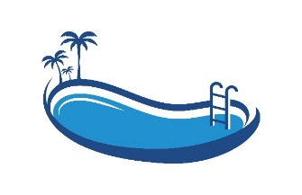
Creating Your Backyard Paradise

QUALITY CONCRETE SWIMMING POOLS
Call Max 0438 188 112 for a quote today

