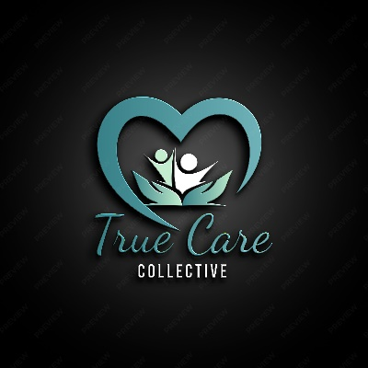

We like this logo but would prefer it with a white background, True Care to be bolder and collective in block letters highlighted with a above and underline, and more green/aqua rather than blue.

We would like to have a modern look that doesn’t look like aged care to reflect fun and modern vibe on support services.

Both Sue & I are former employees of enabling Pathways. We like this website, but we can’t be to similar.

[NDIS Approved Provider for Care, Community & Youth Services - Enabling Pathways](https://www.enablingpathways.org.au/)

Home page- We like “We are a True care Collective” Supports you can count on, care you deserve, with pictures that reflect maybe indigenous, physical and intellectual disability. Maybe down syndrome. Possible not Asian staff due to our local demographic.

Email address

[hello@truecare.com.au](mailto:hello@truecare.com.au) linked to contact us and our website

[Belinda.christie@truecare.com.au](mailto:Belinda.christie@truecare.com.au)

[Susanne.Prosch@truecare.com.au](mailto:Susanne.Prosch@truecare.com.au)

[admin@truecare.com.au](mailto:admin@truecare.com.au)

Can we please have our logos and colours sorted by next week as we will need this for our documents.